Django Static Files Handling

In a web application, apart from business logic and data handling, we also need to handle and manage static resources like CSS, JavaScript, images etc.

It is important to manage these resources so that it does not affect our application performance.

Django deals with it very efficiently and provides a convenient manner to use resources.

The **django.contrib.staticfiles** module

Django Static (CSS, JavaScript, images) Configuration

1. Include the **django.contrib.staticfiles** in **INSTALLED_APPS.**

1. INSTALLED_APPS = [
2. 'django.contrib.admin',
3. 'django.contrib.auth',
4. 'django.contrib.contenttypes',
5. 'django.contrib.sessions',
6. 'django.contrib.messages',
7. 'django.contrib.staticfiles',
8. 'myapp'
9. ]

2. Define STATIC_URL in settings.py file as given below.

1. STATIC_URL = '/static/'

3. Load static files in the templates by using the below expression.

1. {% load **static** %}

4. Store all images, JavaScript, CSS files in a **static** folder of the application. First create a directory **static,** store the files inside it.

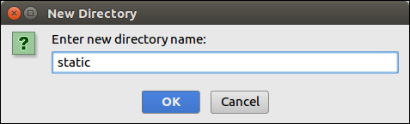

Our project structure looks like this.

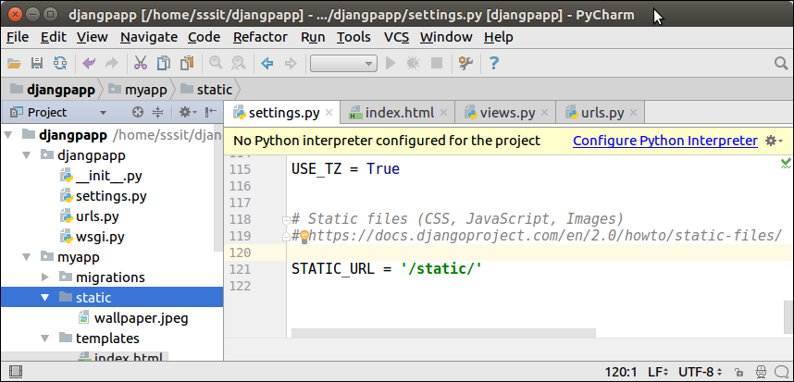

Django Image Loading Example

To load an image in a template file, use the code given below.

**// index.html**

1. <!DOCTYPE html>
2. <html lang="en">
3. <head>
4. <meta charset="UTF-8">
5. <title>Index</title>
6. {% load **static** %}
7. </head>
8. <body>
9. <img src="{% static '/wallpaper.jpeg' %}" alt="My image" height="300px" width="700px"/>
10. </body>
11. </html>

**//urls.py**

1. from django.contrib **import** admin
2. from django.urls **import** path
3. from myapp **import** views
4. urlpatterns = [
5. path('admin/', admin.site.urls),
6. path('index/', views.index),
7. ]

**//views.py**

1. def index(request):
2. **return** render(request,'index.html')

Run the server by using **python manage.py runserver** command.

After that access the template by **localhost:8000/index** URL, and it will produce the following output to the browser.

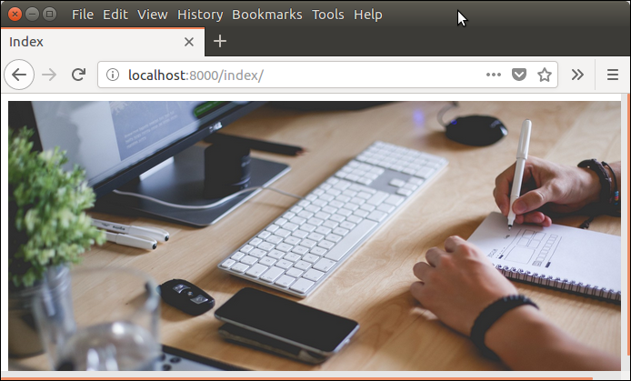

Django Loading JavaScript

To load JavaScript file, just add the following line of code in **index.html** file.

1. {% load **static** %}
2. <script src="{% static '/js/script.js' %}"

**// index.html**

1. <!DOCTYPE html>
2. <html lang="en">
3. <head>
4. <meta charset="UTF-8">
5. <title>Index</title>
6. {% load **static** %}
7. <script src="{% static '/js/script.js' %}" type="text/javascript"></script>
8. </head>
9. <body>
10. </body>
11. </html>

**// script.js**

1. alert("Hello, Welcome to Java");

Now, our project structure looks like this:

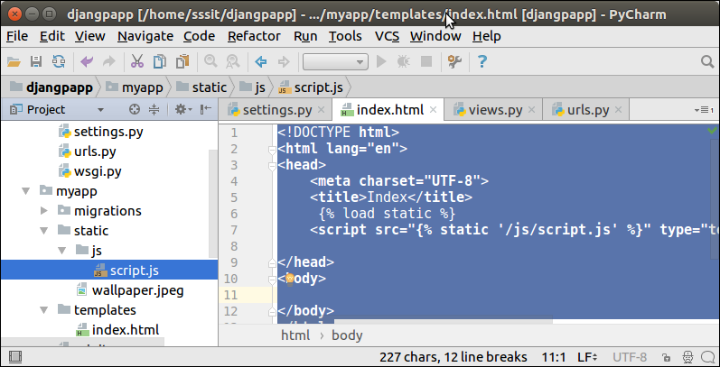

Run the server by using **python manage.py runserver** command.

After that access the template by **localhost:8000/index** URL, and it will produce the following output to the browser.

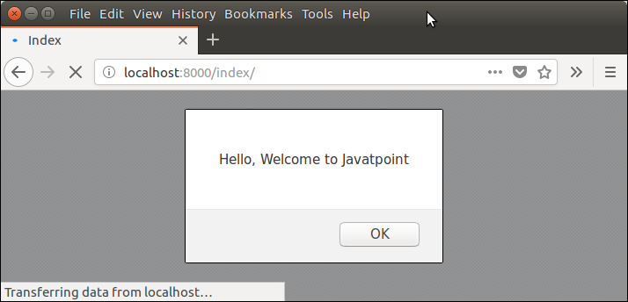

Django Loading CSS Example

To, load CSS file, use the following code in **index.html** file.

1. {% load **static** %}
2. <link href="{% static 'css/style.css' %}" rel="stylesheet">

After that create a directory CSS and file style.css which contains the following code.

**// style.css**

1. h1{
2. color:red;
3. }

Our project structure looks like this:

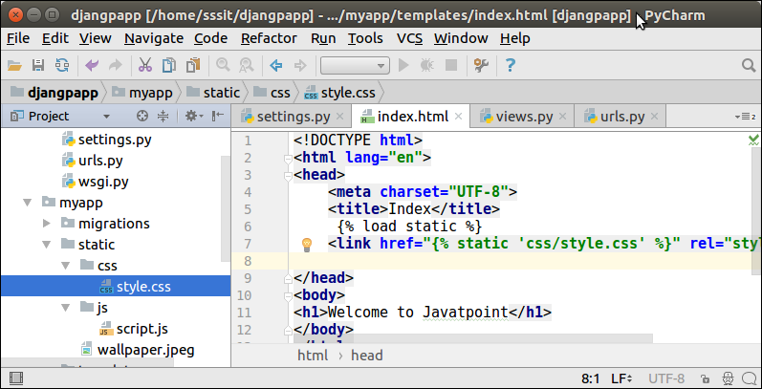

**// index.html**

1. <!DOCTYPE html>
2. <html lang="en">
3. <head>
4. <meta charset="UTF-8">
5. <title>Index</title>
6. {% load **static** %}
7. <link href="{% static 'css/style.css' %}" rel="stylesheet">
8. </head>
9. <body>
10. <h1>Welcome to Javajeeva</h1>
11. </body>
12. </html>